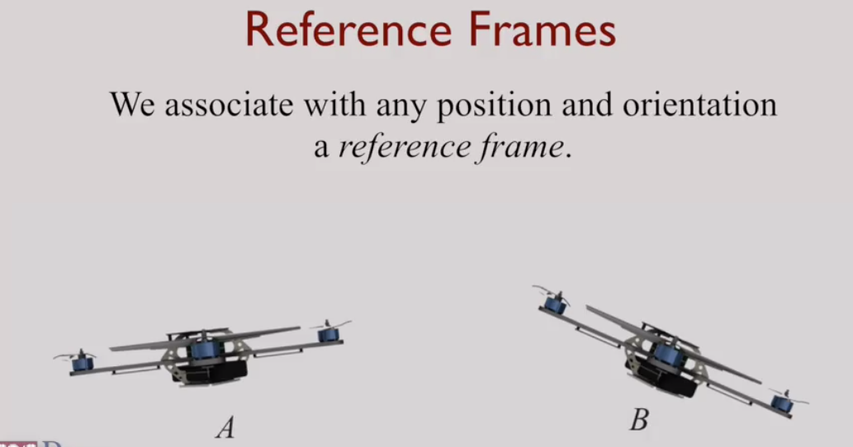

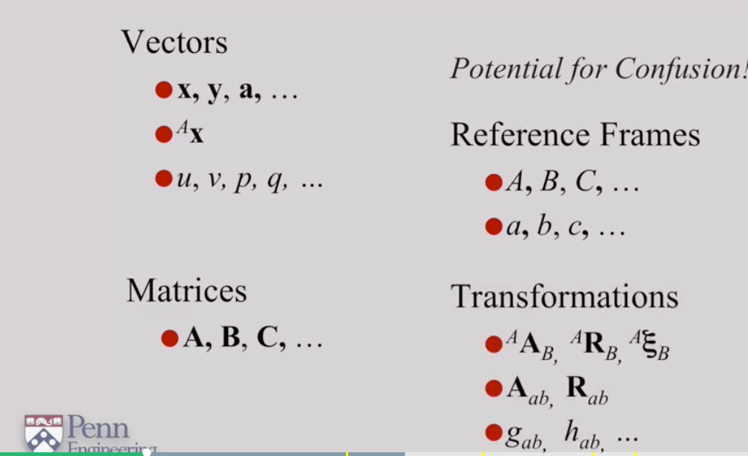

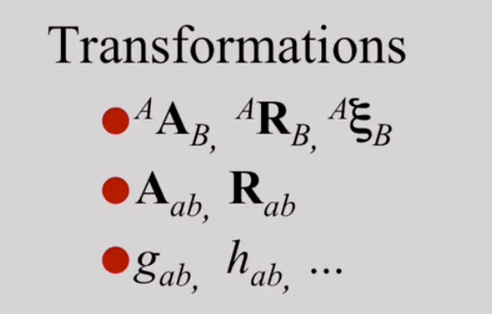

you have an object that transforms vectors in b frame to vectors in a frame

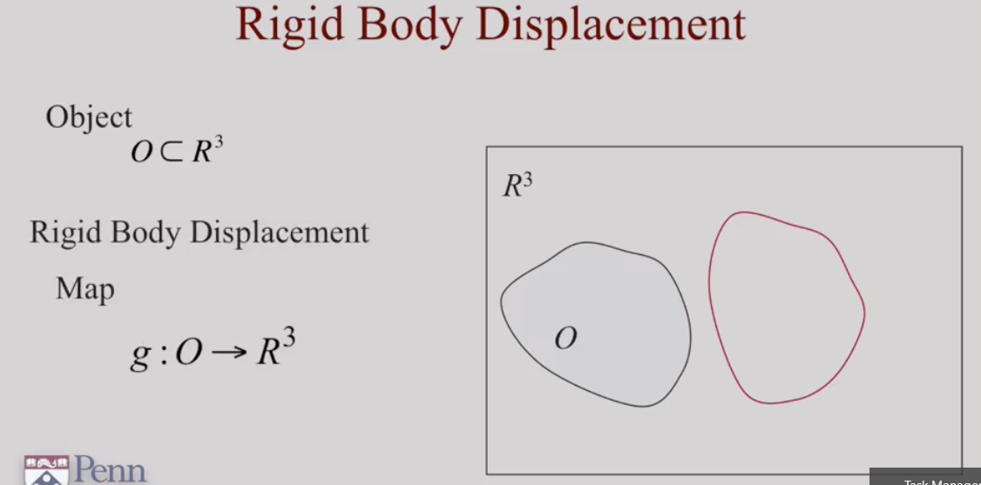

Object O = collection of points in 3D and O is subset of R3

Object O can have multiple positions and orientations

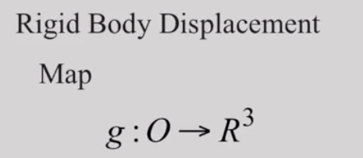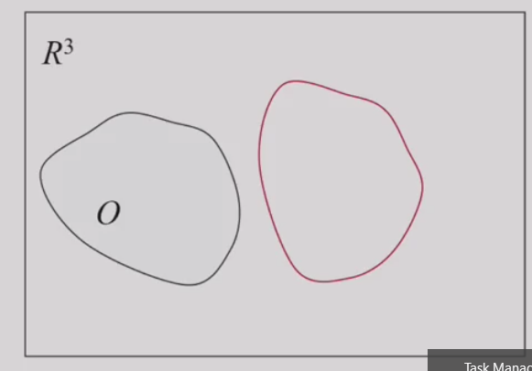

Rigid Body Displacement = is Mapping of all points in O to physical manifestation in R3

Moving of all points in Object O(Black ) to Red lined object

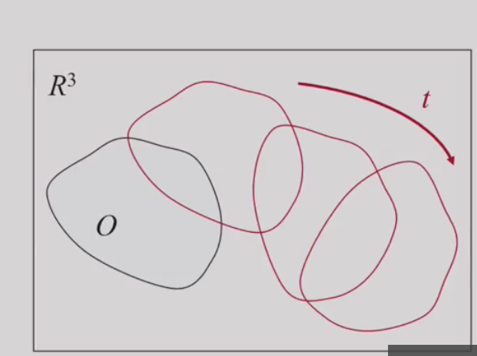 As time Rigid body will have multiple positions and orientations accordingly you have rigid body disp

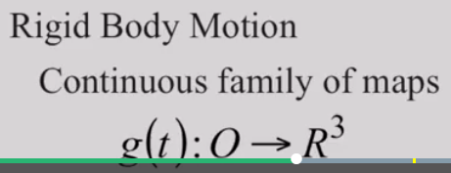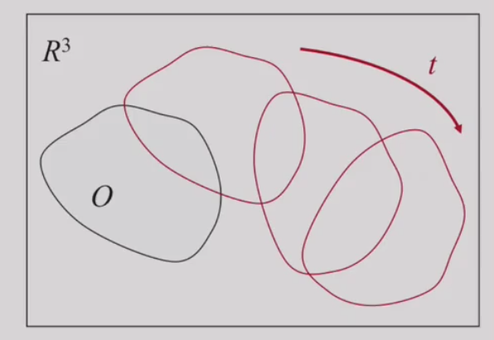

This is How rigid body motion happens🡪 object O in which all points in O are continuously changes po and orientations accordingly you have continuous displacements

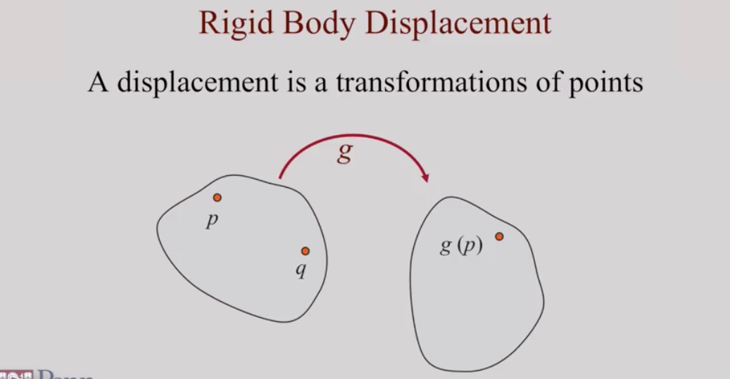

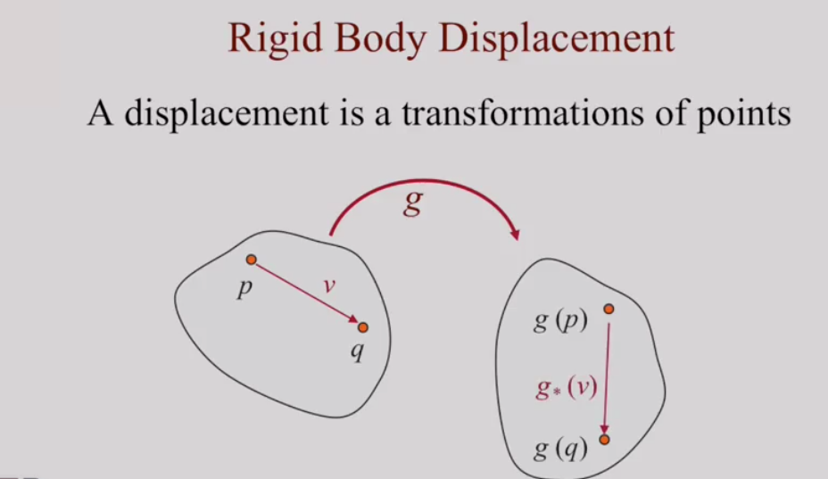

Note: 1.Displacement acts on points

2.g* acts on vectors

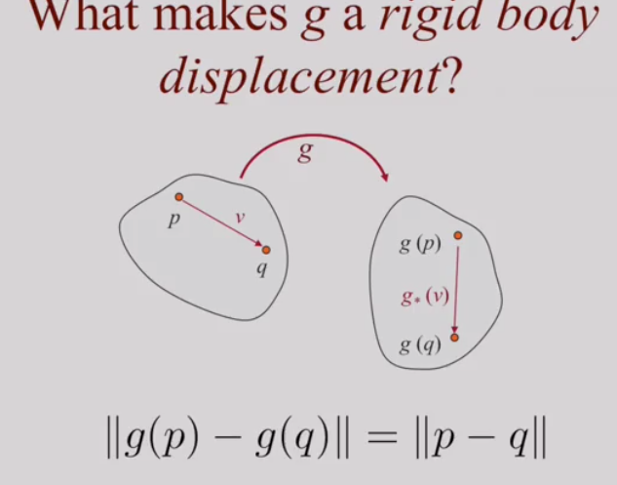

In rigid body disp -🡪 distance between points inside rigid body stays same even after transformation/disp.thats why name rigid

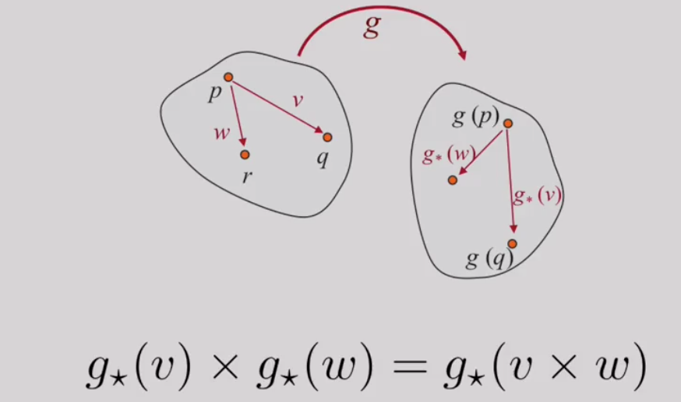

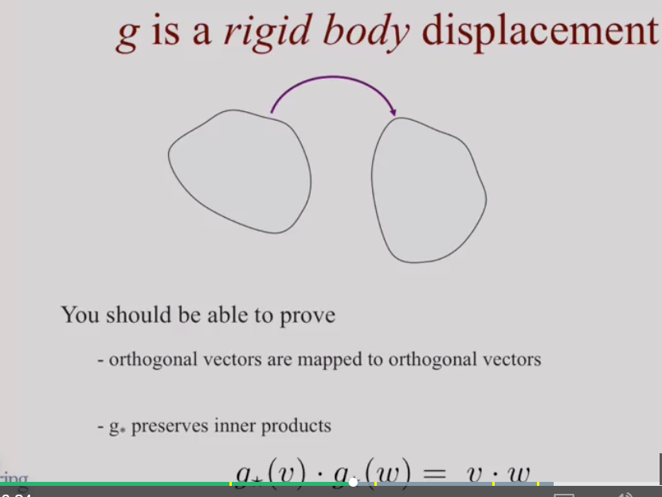

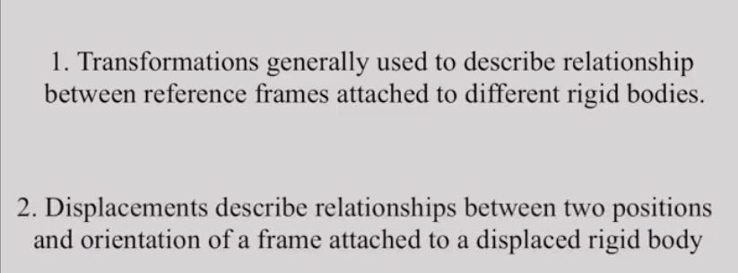

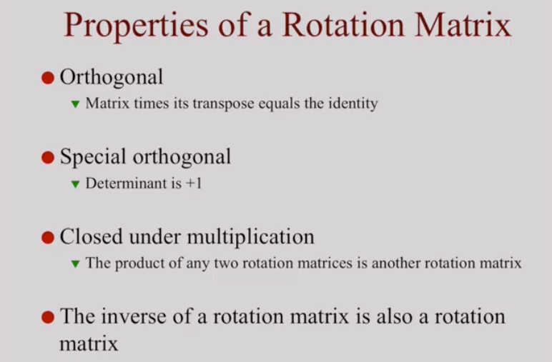

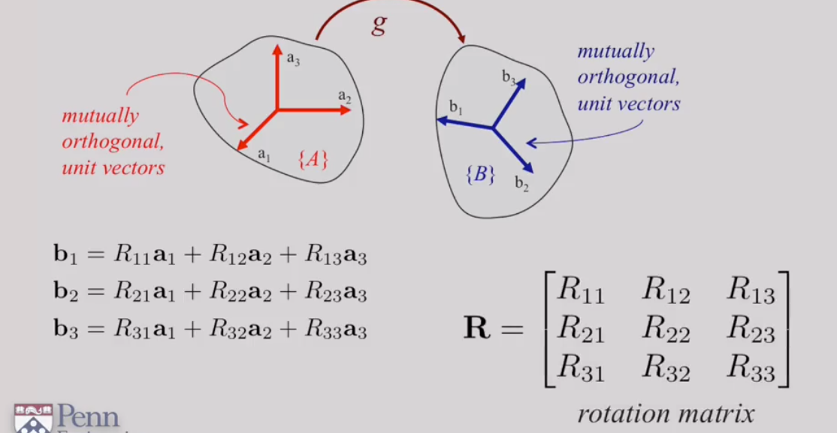

Note : 1. B1=r11a1+r12a2+r13a3 ==🡺 b1 is linear combination of a1,a2,a3

Remember always any vector can be written as linear combination of a1,a2,a3

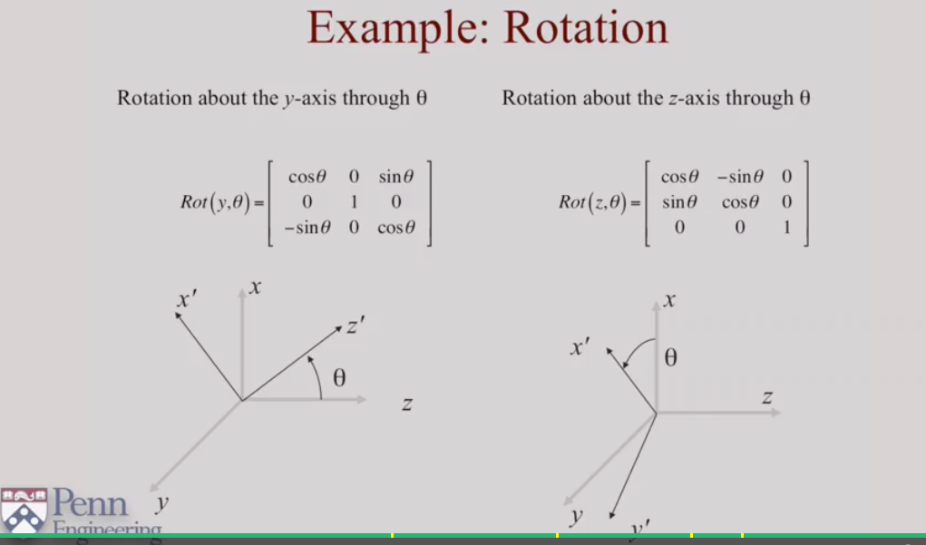

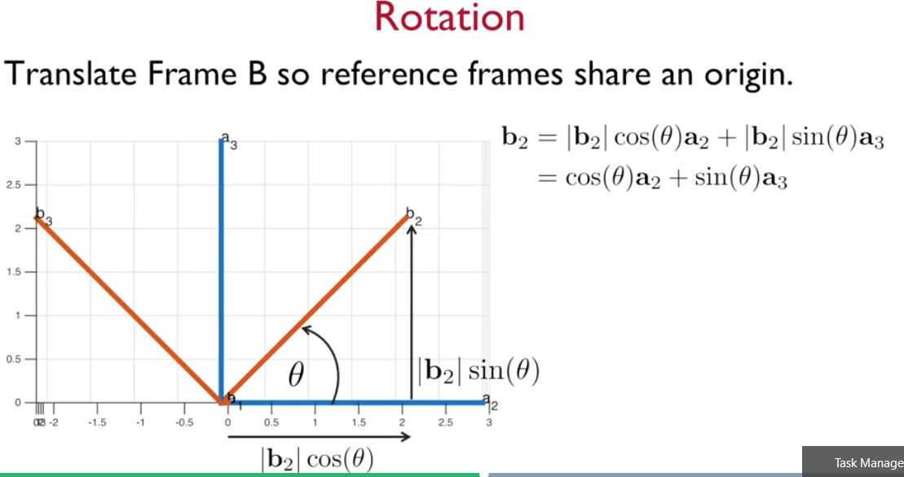

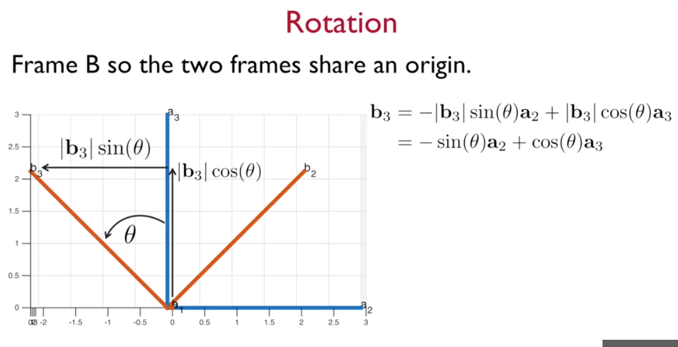

Note: Here a2 is in -ve dir when compared to b3 direction

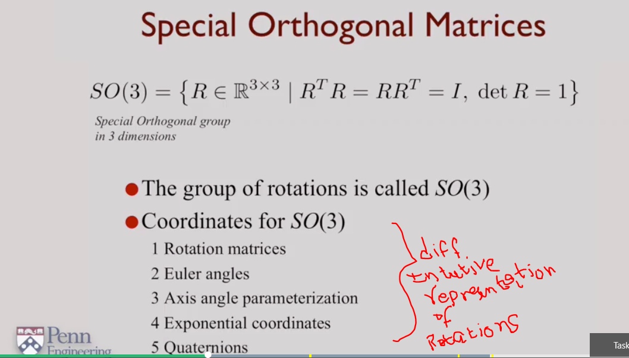

EULER:

Euler showed 3 coordinates are needed to show general rotation,They are 3 euler angles

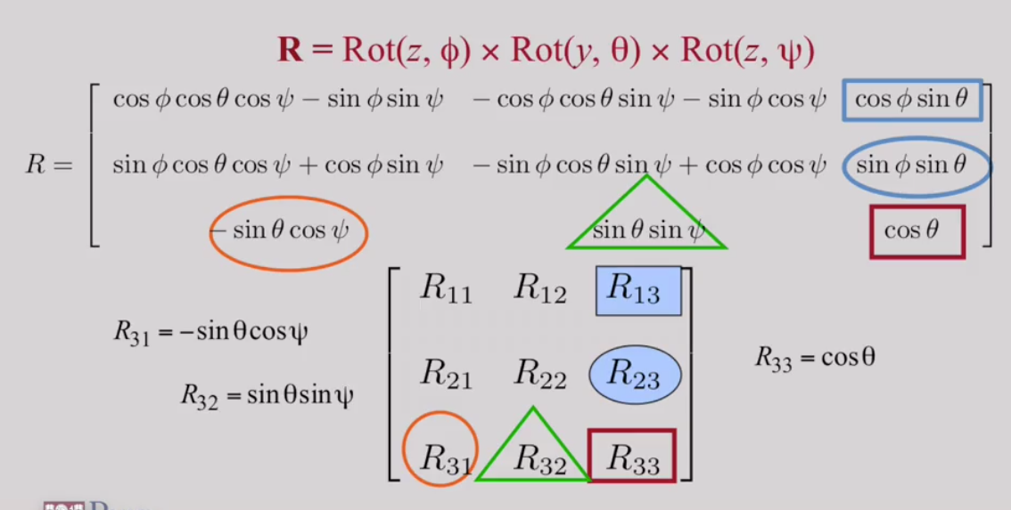

R is 3 euler rotation multiplied result

Now Below is Rotation matrix.

Lets say we know rotation matrix we can fins roll,pitch and yaw of eulers

**Matlab symbols**

